Lecture09
Review of Mini-Dissertation and CHIP Learning Log
Dr Gordon Wright
05 December, 2022

Overview

The week ahead
The week ahead (week 9)
- W9 Personal Tutor session ‘Checking in’
- Any general concerns or queries
- Mini-Dissertation Ethics status
- W10 Cognitive Essay Tutorial
- Psych Society Pub Quiz on Wednesday 7:30 (SU)
- Labs - Ethics, Ethics, Ethics

Mischief Update

You are amazing!

or rather
. . .
Mischief Measured: Development and Validation of a Mischief Typology Measure
. . .
Authors: Goldsmiths Psychology, Class of ’24

Reflective Practice

Metacognition
The process of thinking about ones own thinking
. . .
Most usually with reference to ‘learning’
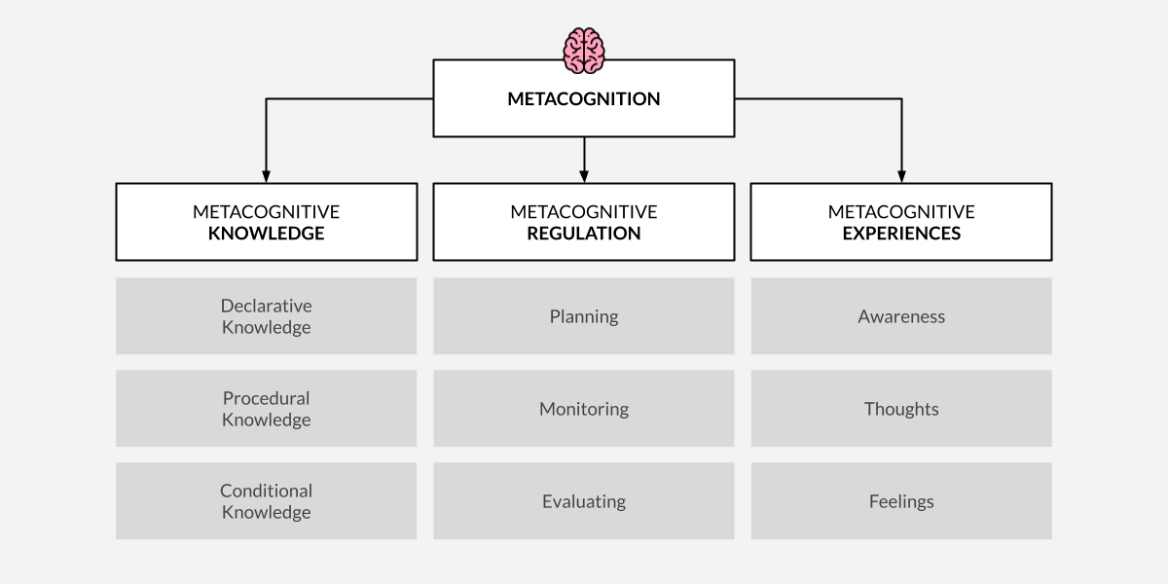

Critical Proposal
. . .
In the most part, the Critical Proposal showed a very high quality of work
. . .
Clear engagement with the critical evaluative process taught last year.
. . .
A modest progression towards the practicalities and process of real research.
. . .
You were required to present a ‘critical reflection’
. . .

Critical Proposal Briefing
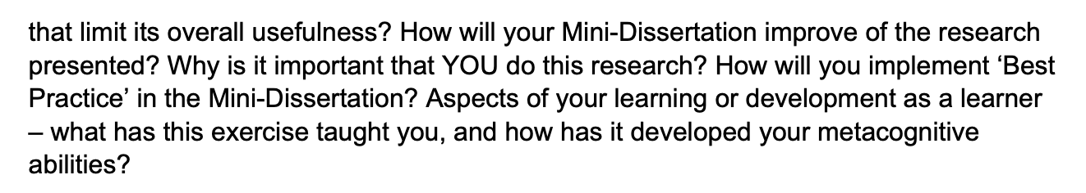

The example given
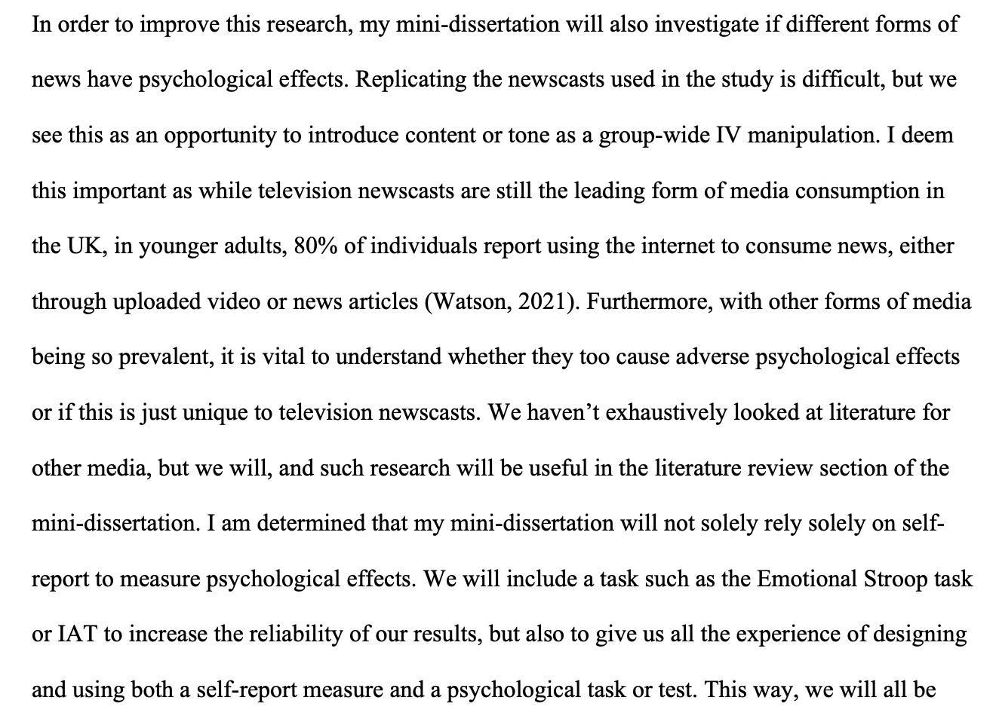

Mini-Dissertation also requires a ‘Reflective Account’
An integral part of the assignment
Worth valuable marks

While we are on the topic
Your ultimate individually written up Mini-Dissertation project MUST conform to the following definitive rules:
2x2 ANOVA design with 2 categorical IVs (each with 2 levels) and a single continuous DV
- You must obtain ethical approval and prove individual involvement in the process of application
- You must make a sample size estimation / Power calculation
- You must collect real data (on- or off-line) and individually contribute to group and cohort data collection efforts
- Open Data (Clearly labelled .csv file e.g. Excel, with codebook or explanations of variables)
- Open Materials (All materials relevant to the task in as immediately reproducible a format as possible - stimulus sets, stimulus creation instructions, scripts or code, experiment design information e.g. random allocation techniques)

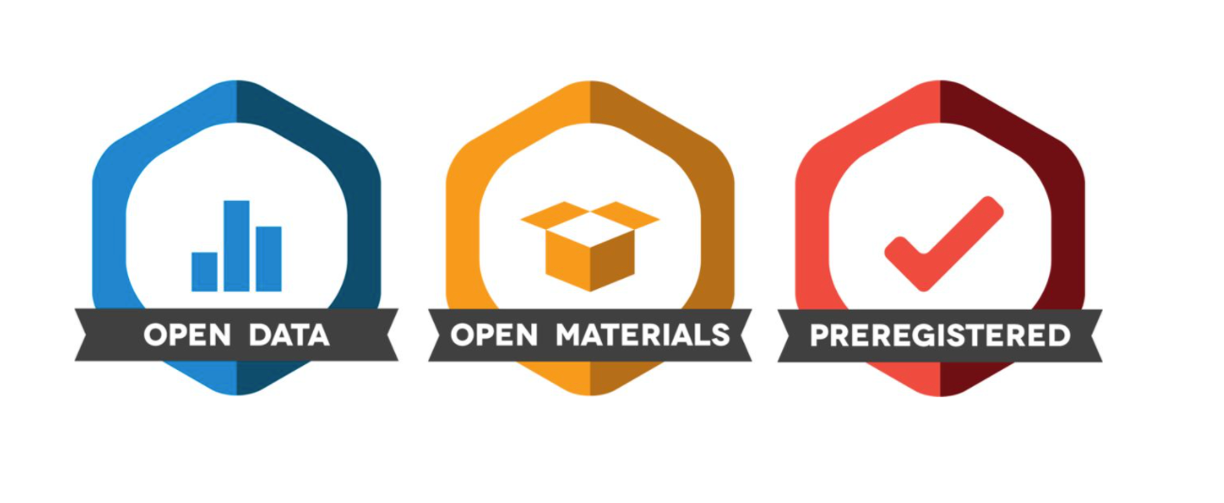

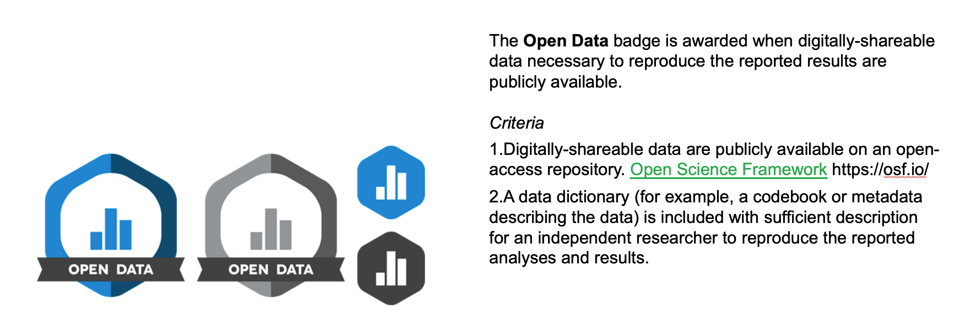

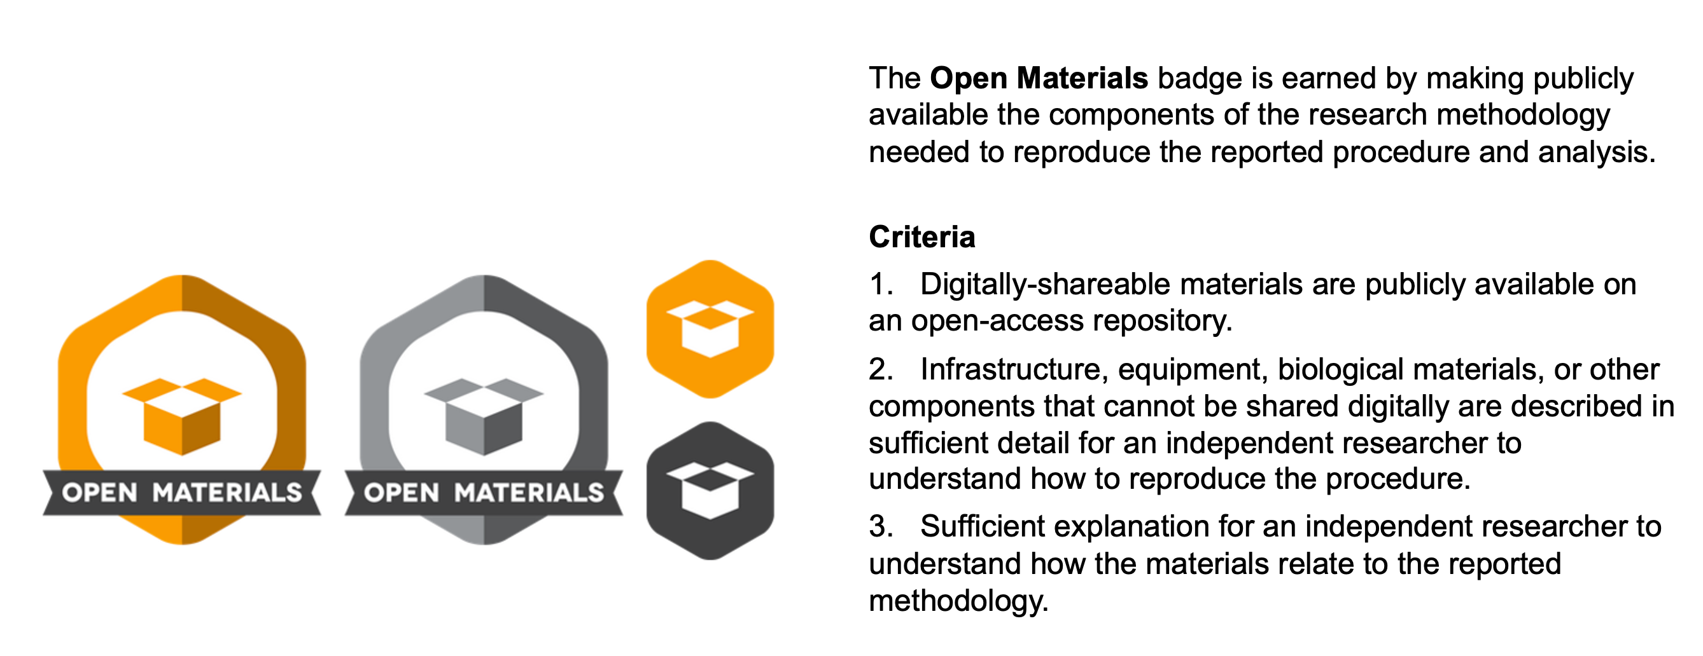

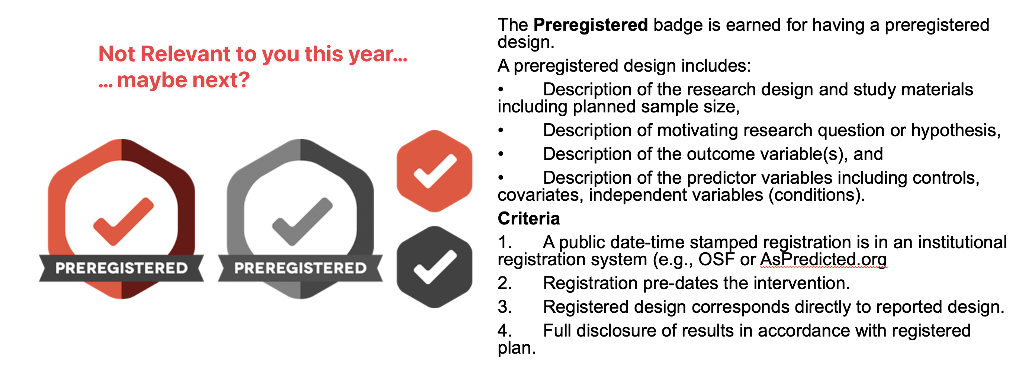

CHIP Learning Log
Designed to introduce you to:
- Conceptual and Historical & Integrative issues in Psychology
- Big picture stuff! Controversies!
Traditional topics are:
- A history of Paradigms in Psychological Research
- Psychology as a Science
- Evolution
- Consciousness

Surprise* hit last year
Inclusivity – 2 lectures from Dr Tegan Penton
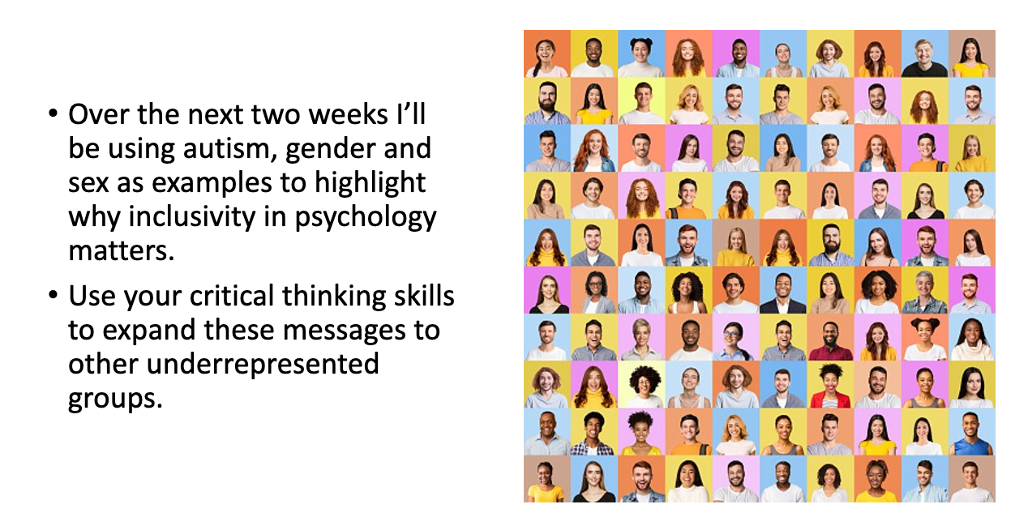

CHIP Assignment(s)
- Coursework piece designed to allow you to engage reflexively with the ‘big picture’ of your degree
- Think about how these issues link into psychology as a discipline, and how they relate to your own thoughts about what psychology is or should be
- Two essays of max 700 words each
- Marks are awarded for reflection, evidence of learning and bring topics together. Please see marking criteria for both essays.
- Not looking for a restatement of the facts in the lectures etc.
- They are designed to be personal and reflective – embrace this aspect!

Essay 1
Essay 1 is based on the content of ONE of the topics and should adopt at least two of the following 6 ‘perspectives’.
  - As a STUDENT of psychology
  - As a TRAINEE psychologist
  - In relation to a RESEARCH application in your future
  - As an HISTORIAN of psychology
  - Reporting on the culture or PRACTICE of psychology as it currently exists here or across cultures
  - As a critic or supporter of psychology’s status as a SCIENCE

Essay 1 tips
  - Ask a specific question – and answer it.
  - Intro, body, conclusion structure.
  - Reflect on the topic and give your own opinion as to the answer!
  - Present a journey in your learning or appreciation of the topic
  - Ensure your answer is argued using examples
  - Use evidence in your argument from a range of sources, ideally do some strategic wider reading
  - Present and reference it well

Essay 2
Essay 2 should focus on at least one of the OTHER topics covered in the course.
  - This answer should focus on a primary reading associated with the lectures and then any further reading you have done (strongly encouraged).
  - You must identify that primary reading explicitly in the essay itself.
  - You should not simply restate what the authors thought or found, but rather briefly summarise the point that stimulated your interest in the reading and use that as a springboard to discuss the topic or issue.
  - Think about your perspective on the issues.
  - What do you think about this debate or issue? We want to know!
  - And what do you think are interesting directions for psychologists to take this debate or issue in the future?

Essay 2 tips
  - Explicitly identify a single initial reading and build upon that.
  - Discuss a debate or issue that you think is interesting or important
  - Give your own opinion and how this has developed or changed as a result of the lecture, the course more widely, and/or the reading.
  - Argue your opinion explicitly, own it and back it up with examples
  - Use evidence in your argument from a range of sources, ideally do some strategic wider reading
  - Present and reference it well

Overlapping content
  - You can combine across different topics in Essay 2 (e.g., you could talk about Evolution and Consciousness, or Inclusivity and Science), and thinking about links between topics is strongly encouraged.
  - However, the material covered in Essay 2 must be different from Essay 1. Students will be penalised for covering identical topics.

Details
  - Due 10 am 21st April 2023 - about 3 weeks after the end of term
  - Both answers should be written in essay-style prose (e.g., with APA references where you refer to sources) put in a single document and submitted to the coursework submission page.
  - Max 700 words per answer (references not included in word count)
  - Remember that this only accounts for a smaller portion of the module grade (15%). Should hopefully be an enjoyable way to reflect on issues on the course you found interesting.

Essay 1
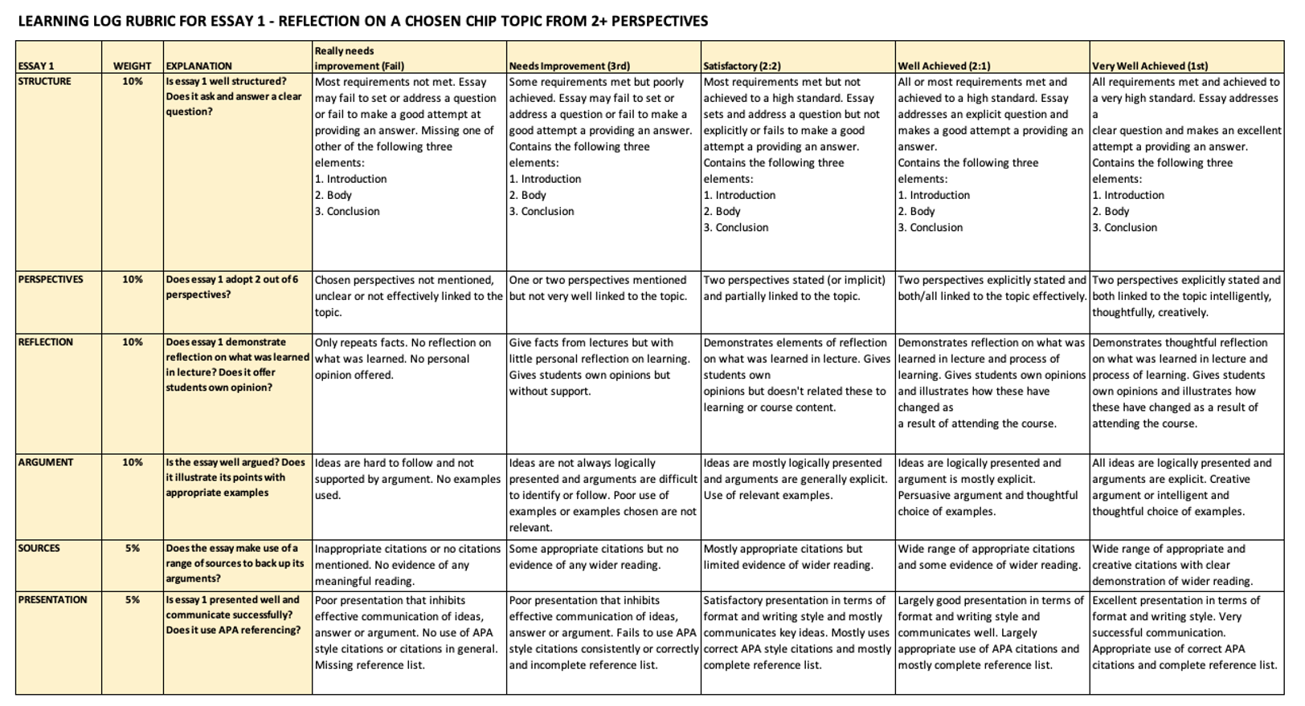

Essay 2
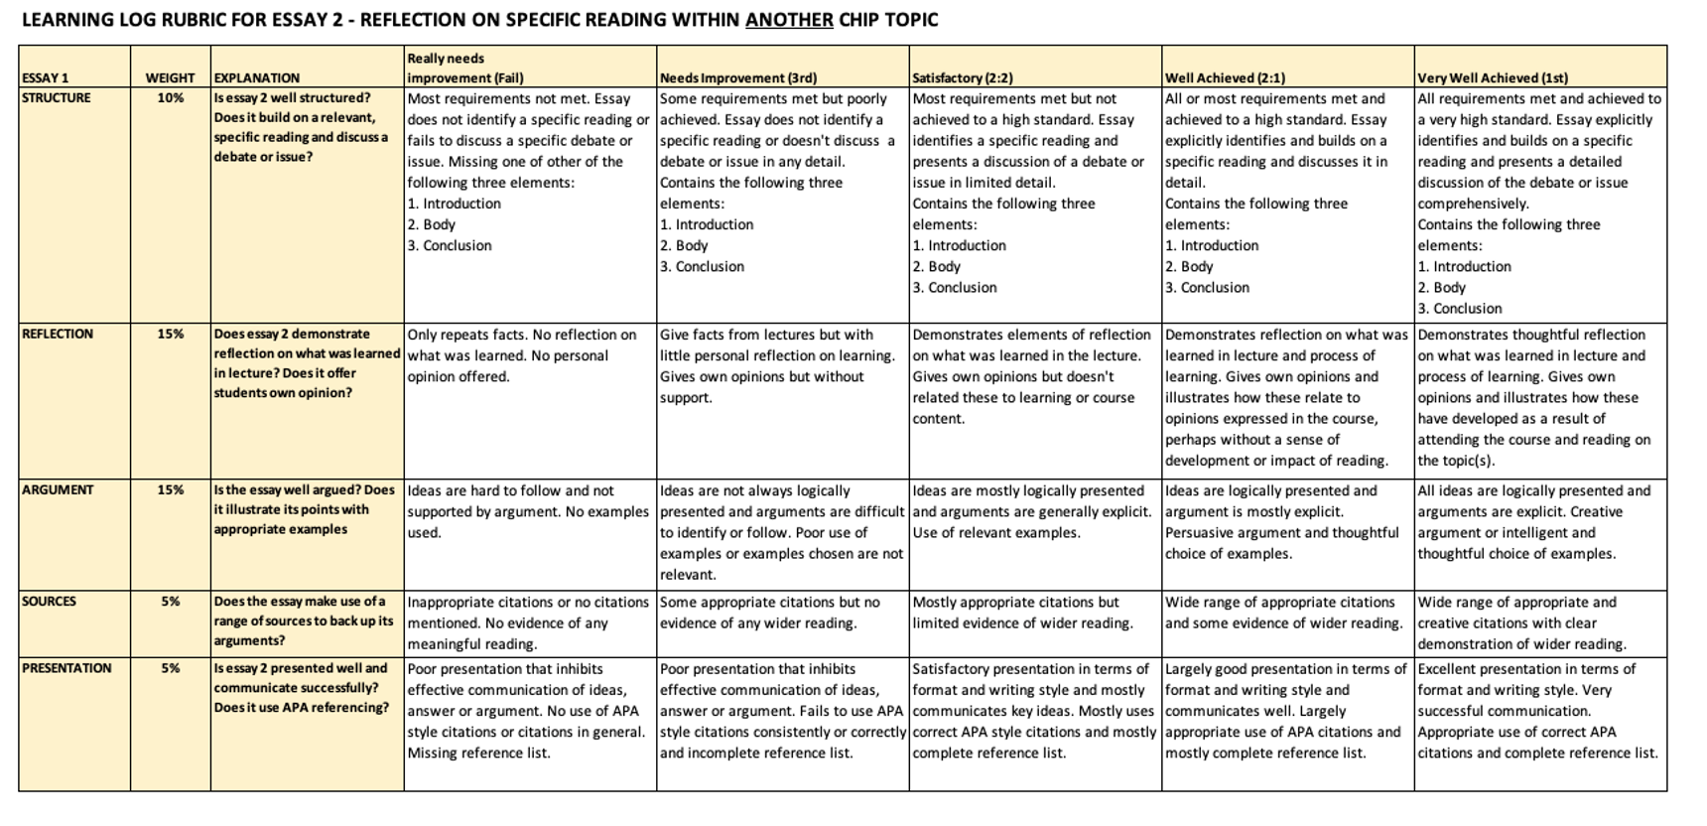

Any questions?

Have a great week!

