Lecture02
Asking good questions and gathering reliable evidence
Dr Gordon Wright
10 October, 2022

Key topics today
- The week ahead
- Some Induction Week Poll insights [in the lecture]
- The research process you are beginning
- A couple of CHIP topics to vote on
- Lab preview - The process, time-management and teamwork

The week ahead
This week (week 2) you have your Social Psychology Essay Tutorial
“Sexual Economics: Theory and Patriarchy”
“Is sex a female commodity that women exchange for men’s resources? Advantages and disadvantages of applying social exchange theory to understanding heterosexual relationships.”
Deadline 10am Friday 21st October (end of week 3)
Feedback on/by 11th November
Mention Roy Baumeister. A very creative Psychologist

Induction Week Poll
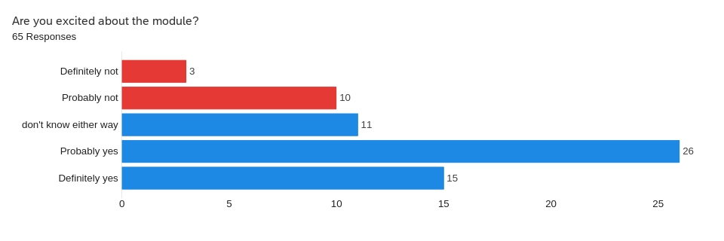

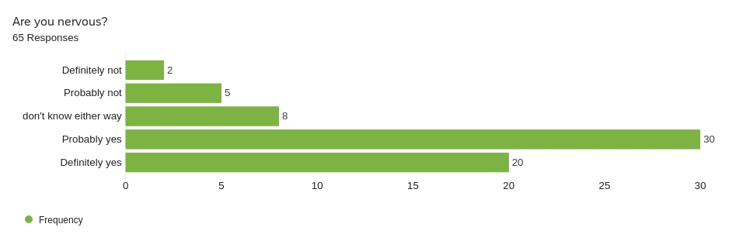

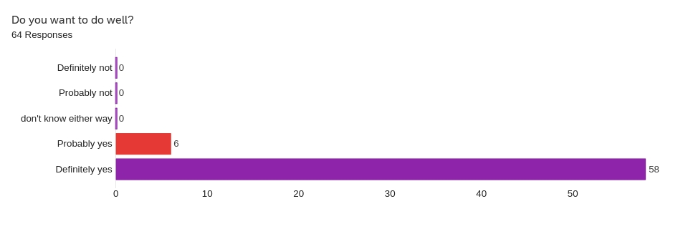

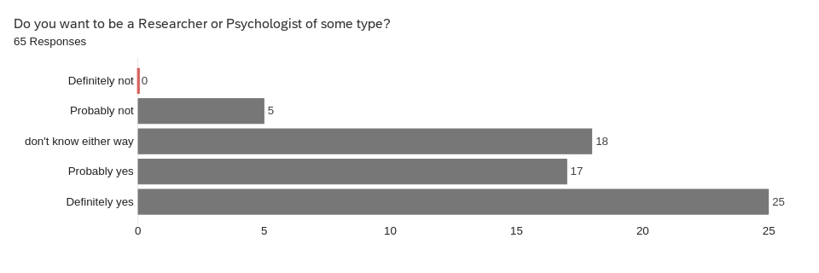

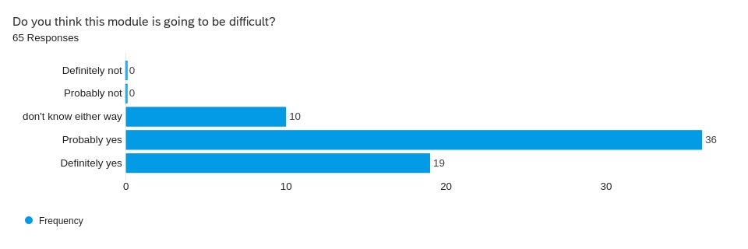

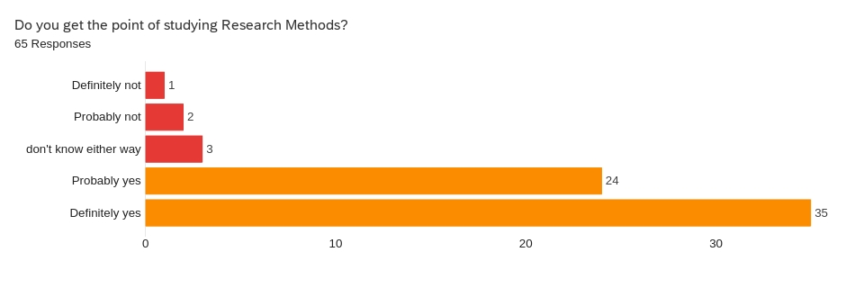

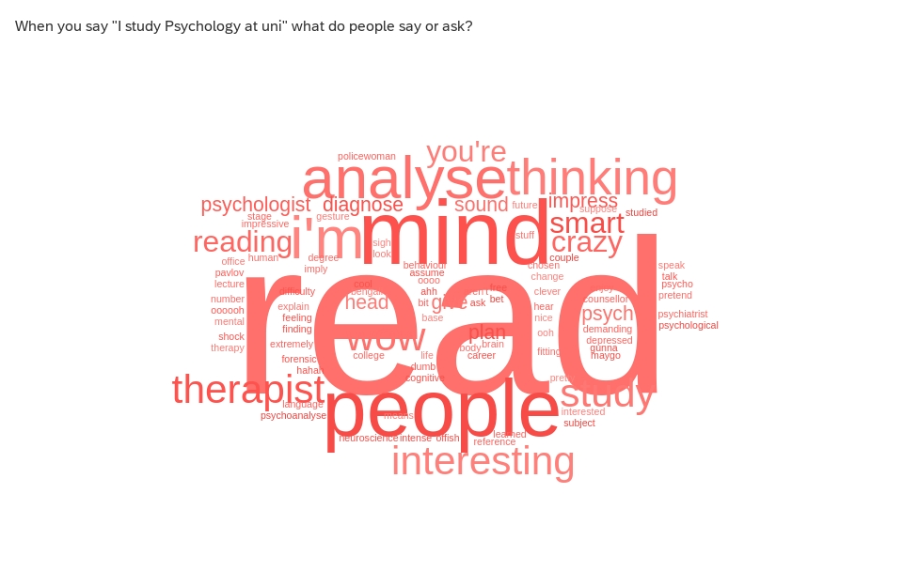

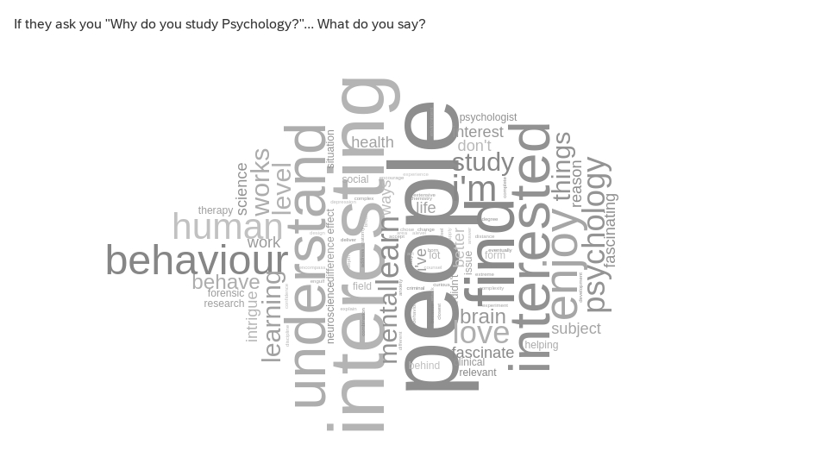

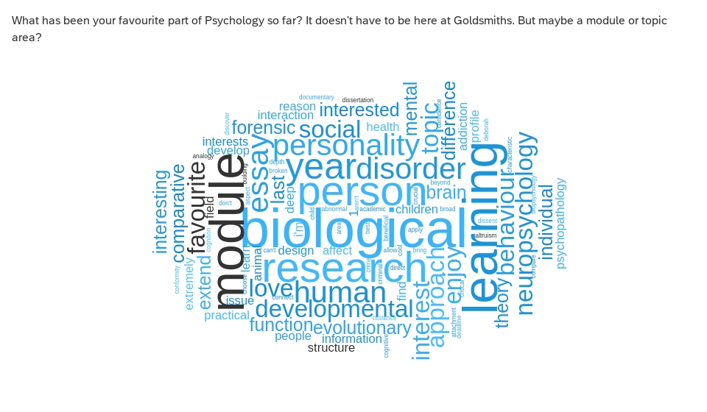

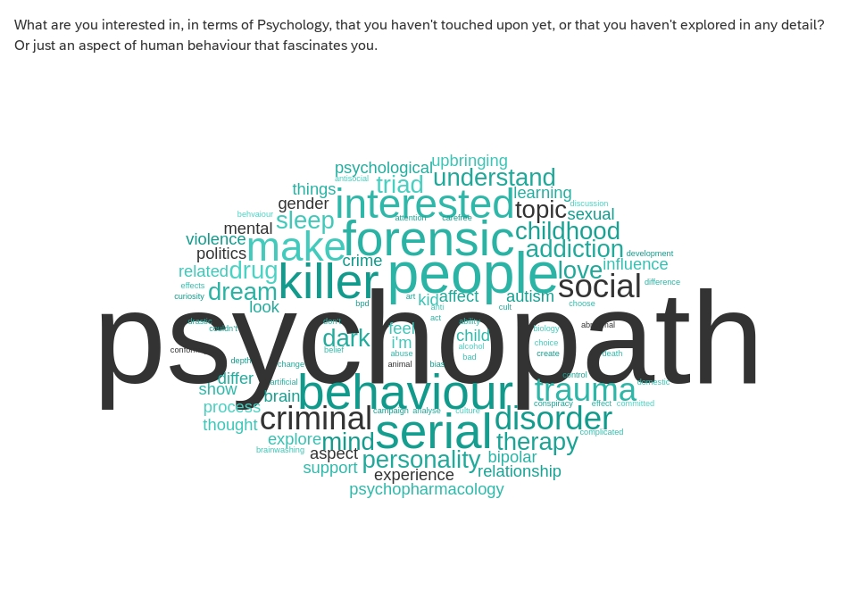

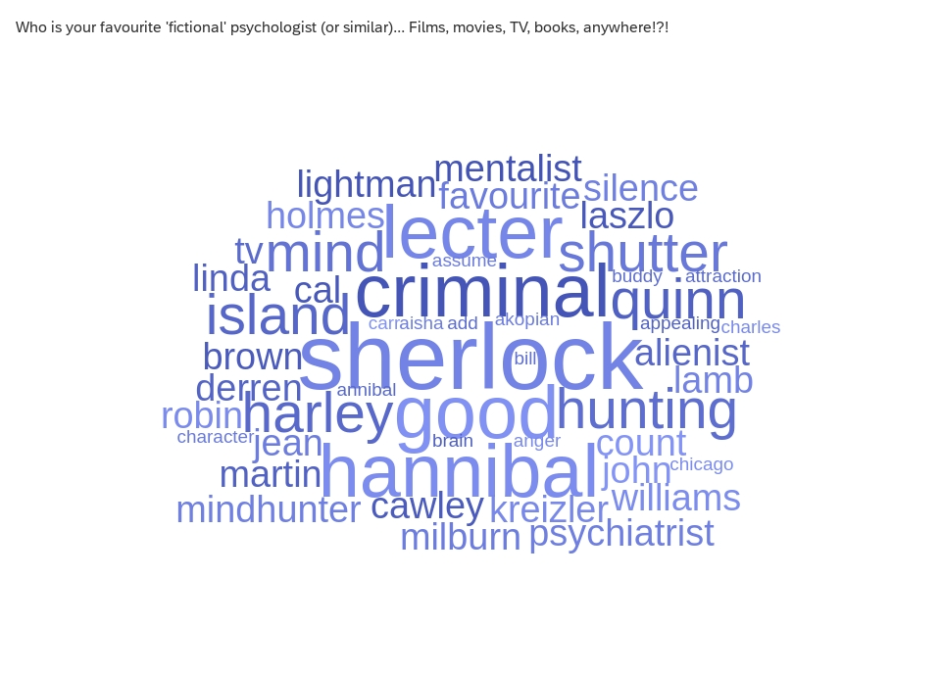

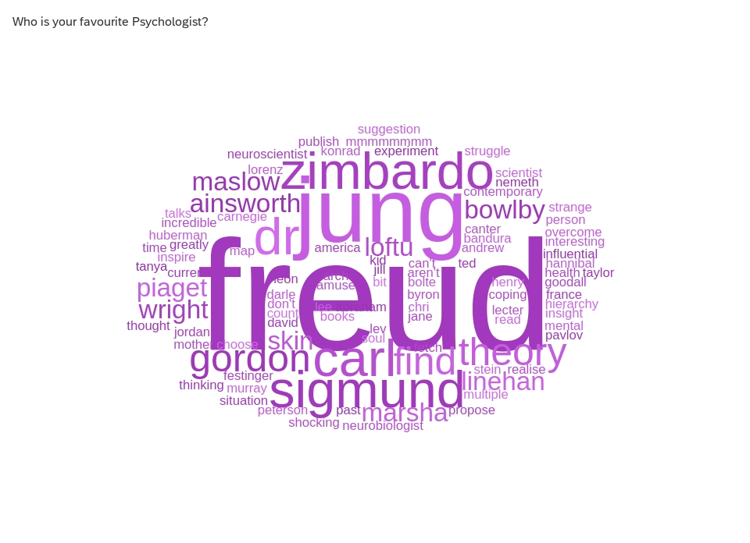

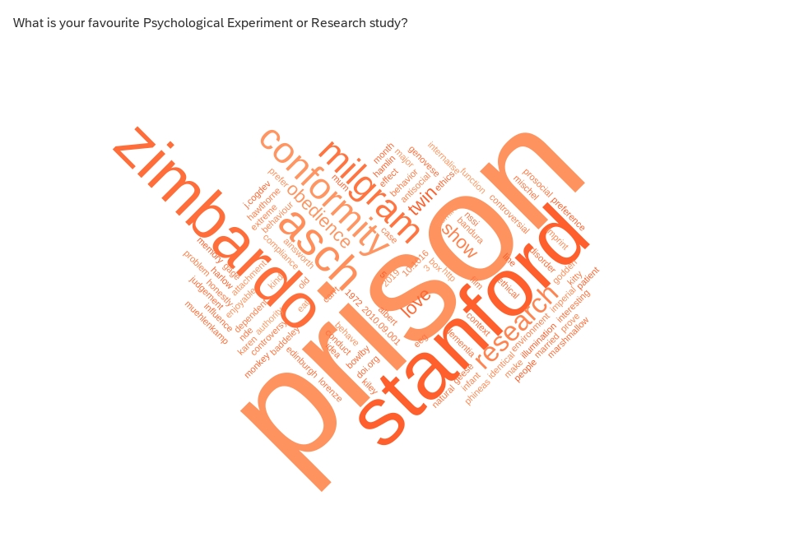

Did you break out the popcorn for the ‘Prelude’?

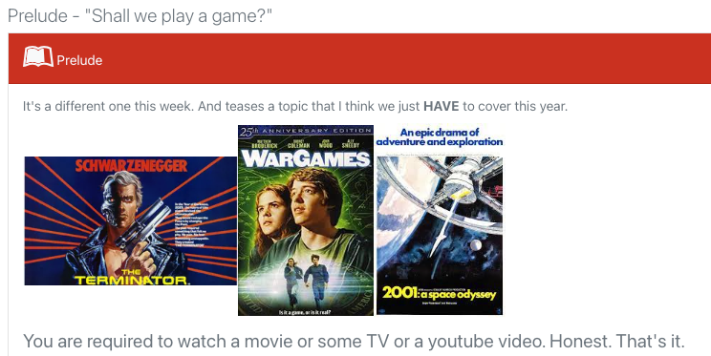

Did any of you enjoy my movie recommendations?
Did you pick up on the theme?
I’d actually already kinda introduced it…

from last week
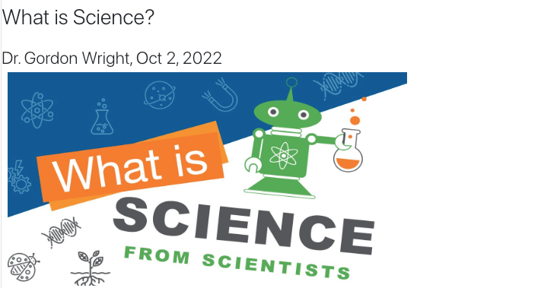

A confession
- I didn’t make that article ‘I’ wrote terribly obvious
- for a reason
- it felt a bit weird
- I didn’t write it
- But there isn’t really anything stopping me claiming so…
- Or is there?

A conundrum
I’m going to be fiercely recommending the use of AI tomorrow.
And ALSO warning you against its use elsewhere
huh?

CHIP topics
I want to briefly draw your attention to the third (final) piece of coursework for this module, the so-called ‘CHIP Learning Log’
The earlier we flag topics and introduce little glimmers of content, the easier that will be.
1 - What is Science? An amazing opportunity to consider this while you do your Mini-Dissertation
(A more reliable overview from Professor Ed Diener here) Open Educational Resource
Diener, E. (2022). Why science?. In R. Biswas-Diener & E. Diener (Eds), Noba textbook series: Psychology. Champaign, IL: DEF publishers. http://noba.to/qu4abpzy
2 - Artificial Intelligence - Promise or Peril?

CHIP topic approval process
Anyone can suggest a topic, by identifying where it sprang to mind.
people need to approve it by confirming it is relevant, with a brief rationale.
The more you engage, the more topics you get to choose from.
- A concept or debate within Psychology
- A historical issue or controversy
- A methodology or approach and its promises or limitations
- A distinctive or divisive topic
- A modern innovation or applied challenge
https://www2.open.ac.uk/openlearn/CHIPs/

A psychologist? A scientist?

Prize for guessing my favourite Psychologist

Scientists base their ‘claims’ on EVIDENCE
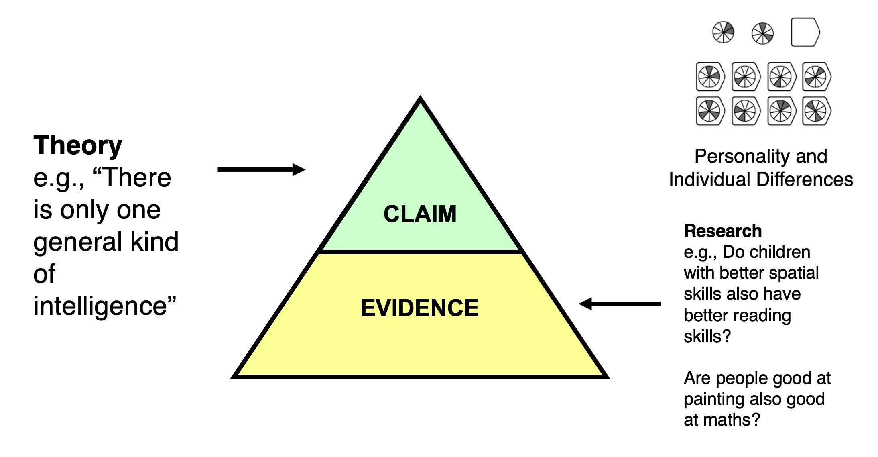

Evidence quality = claim quality!
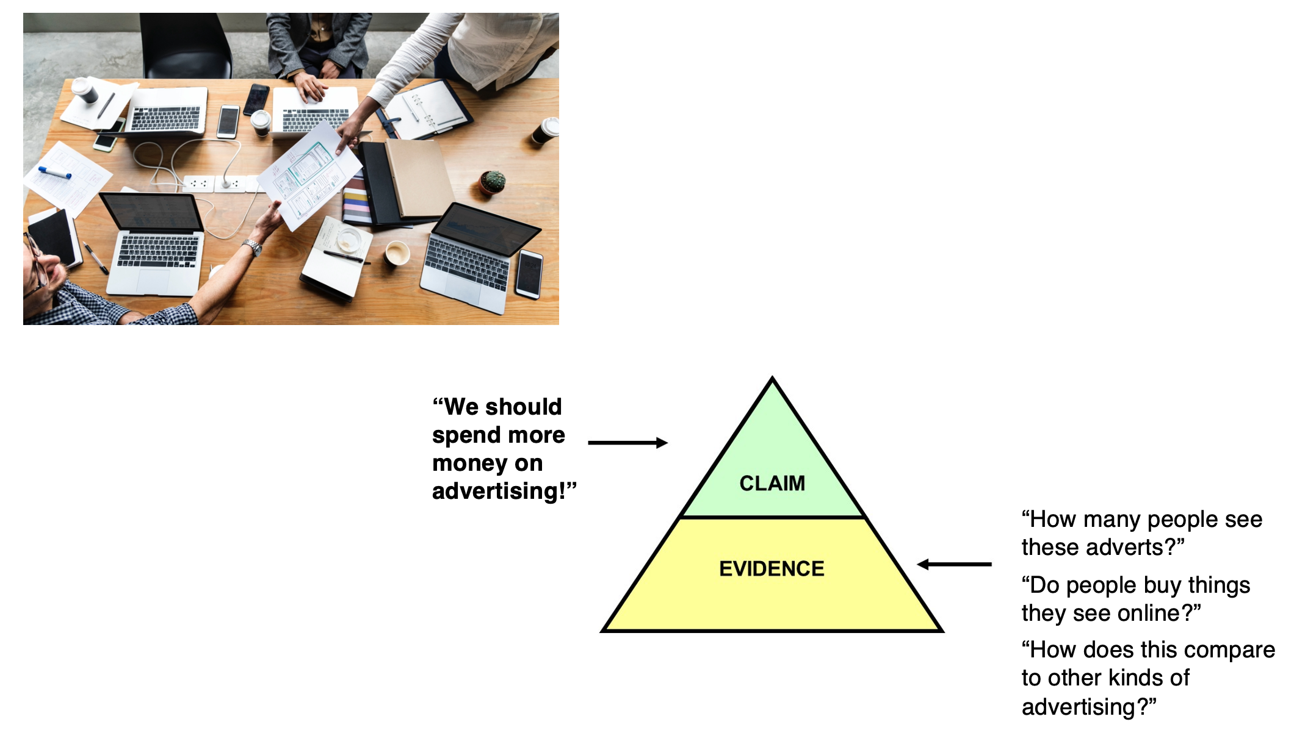

It starts with a hypothesis
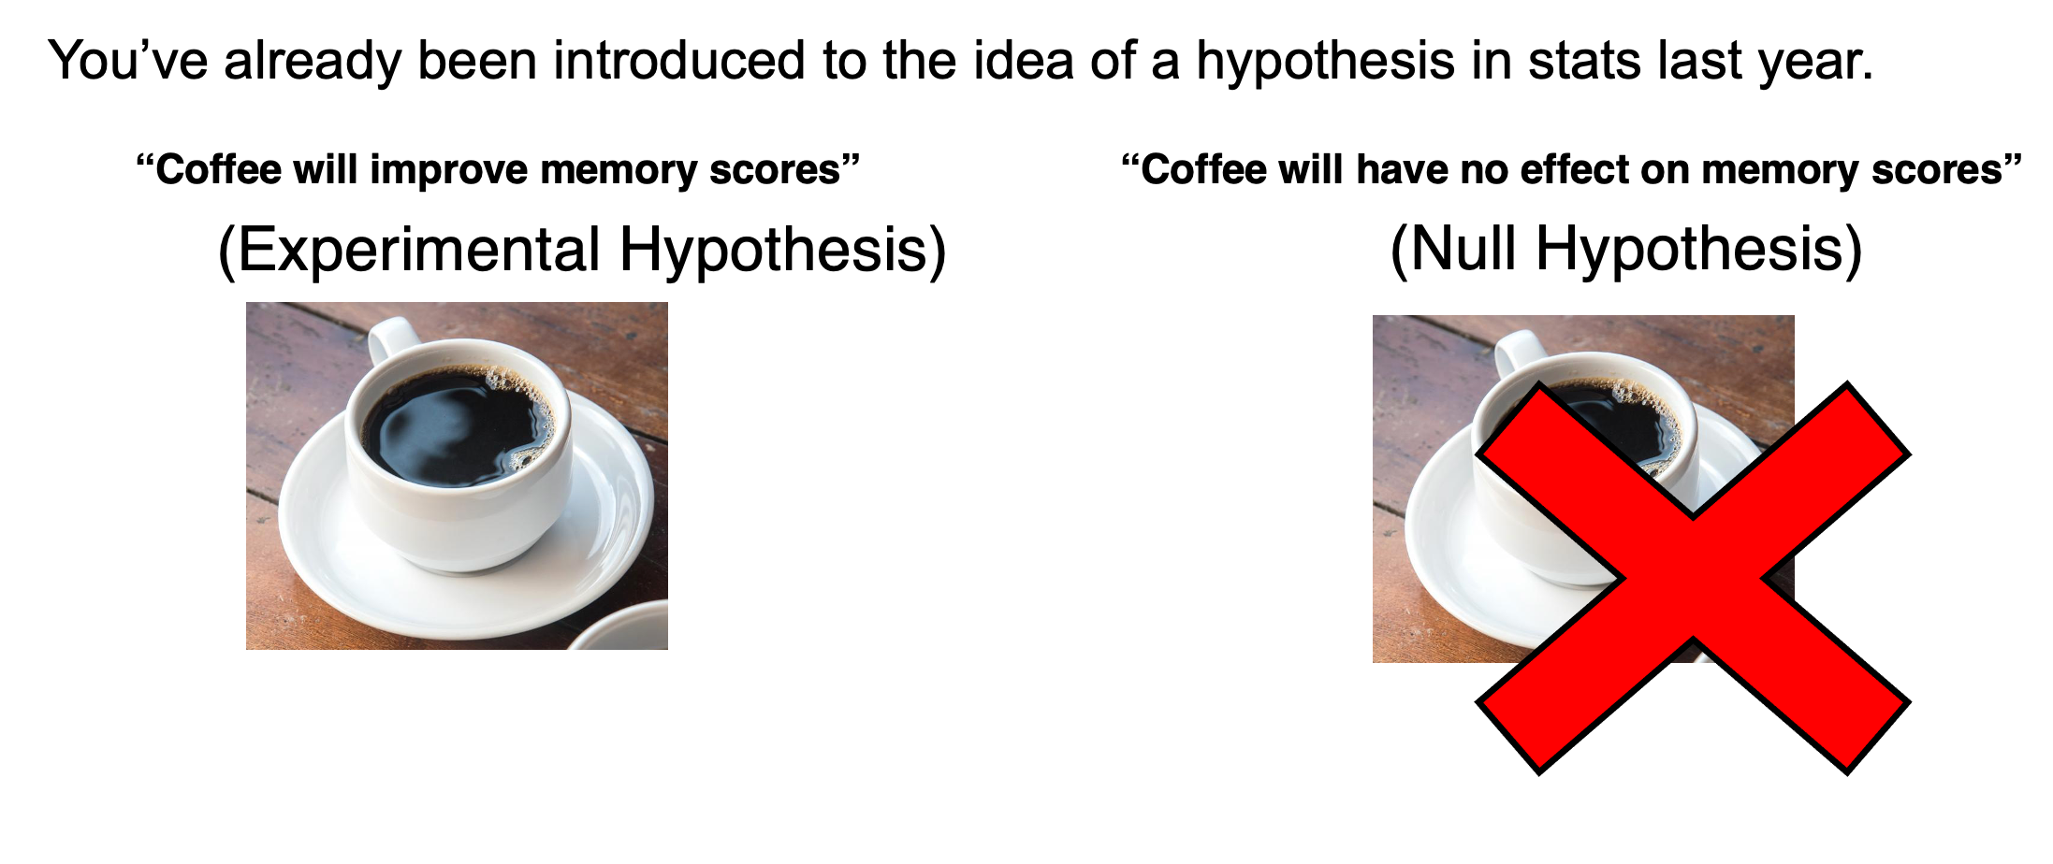

recap on hypotheses
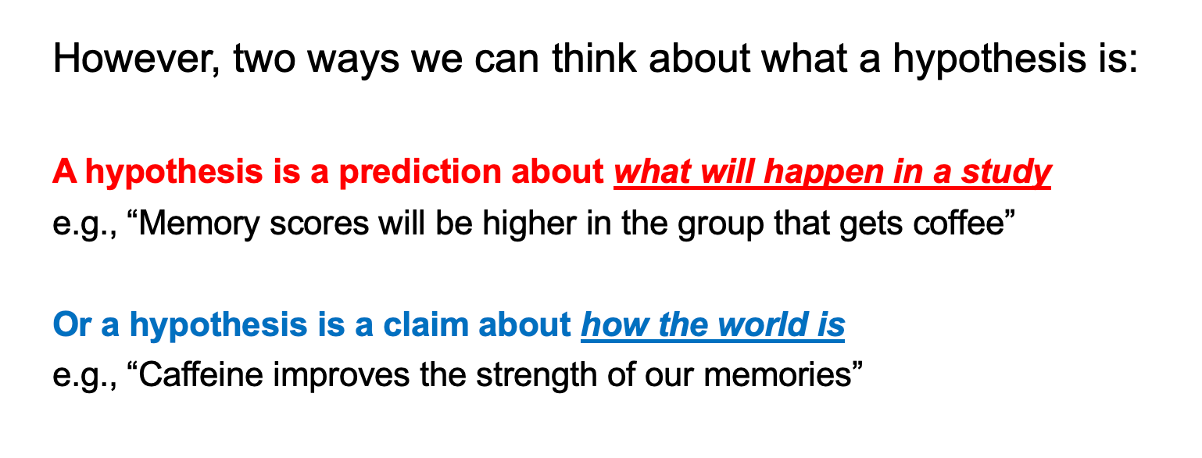

The research process
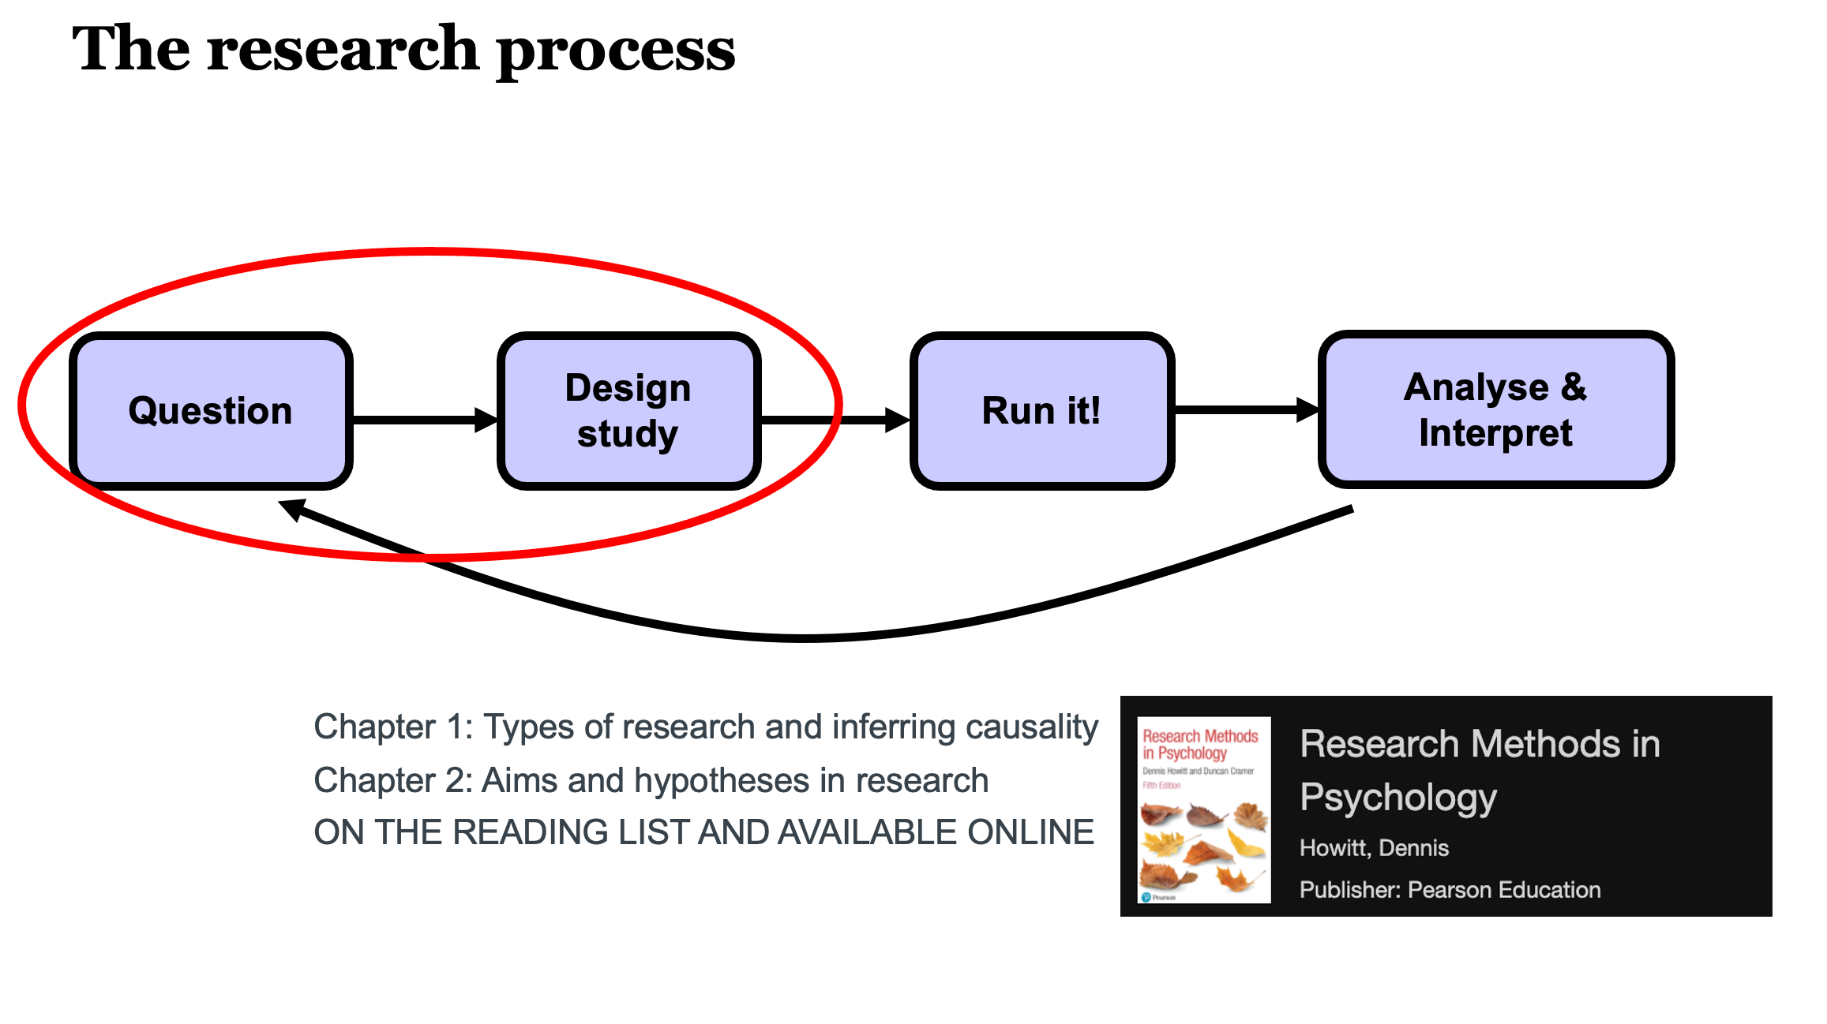

The simplicity of an experiment
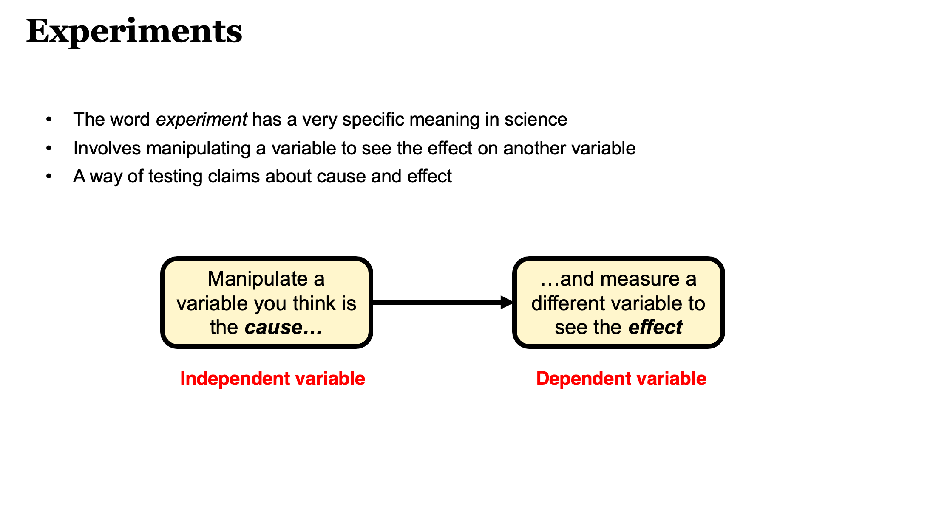

Operationalisation
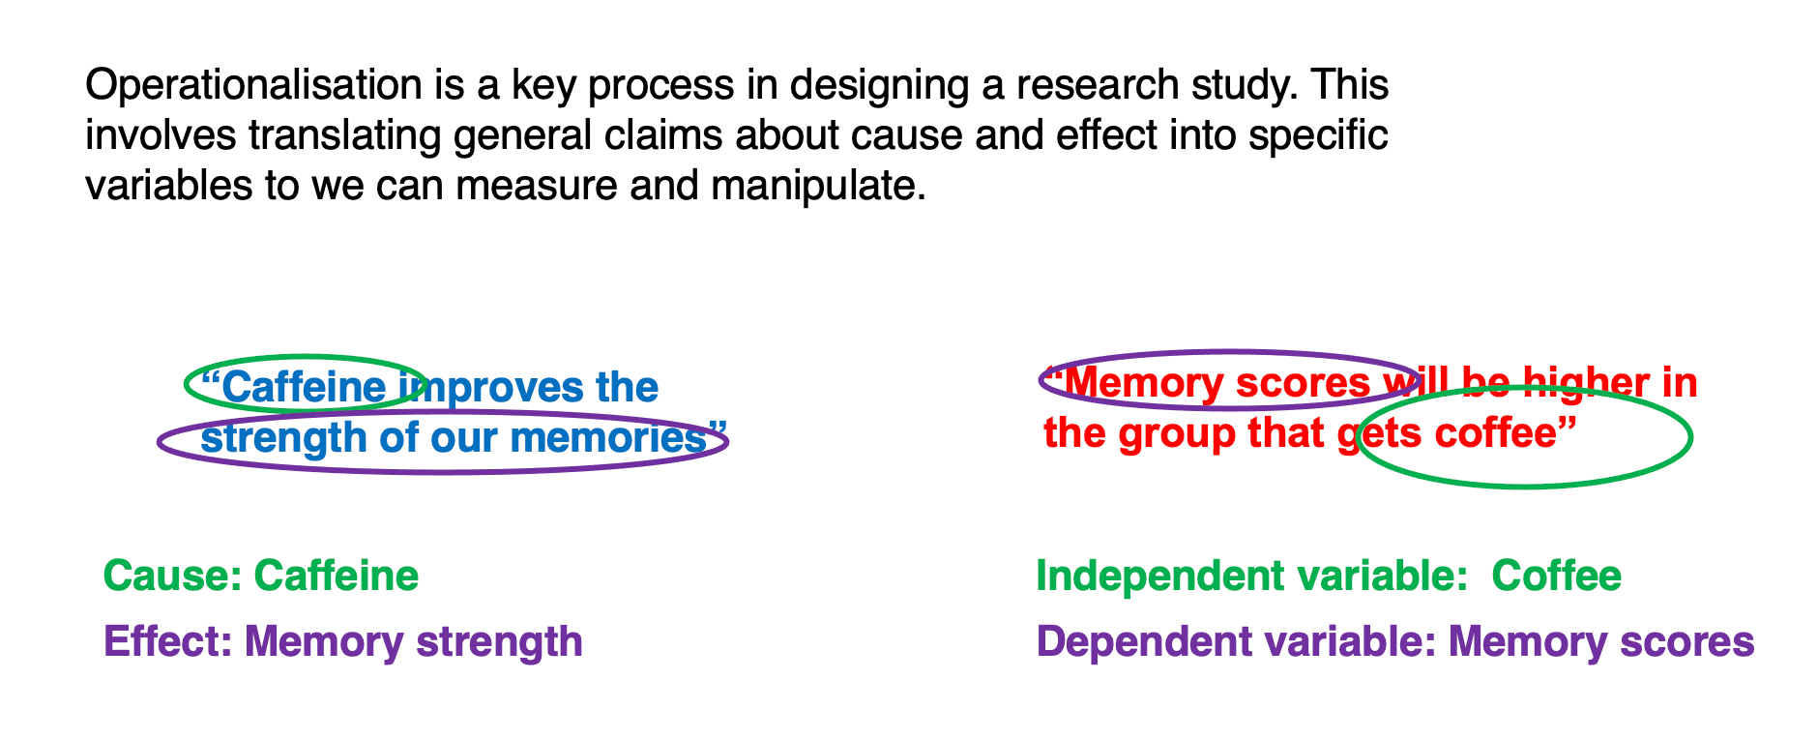

The challenge of operationalisation
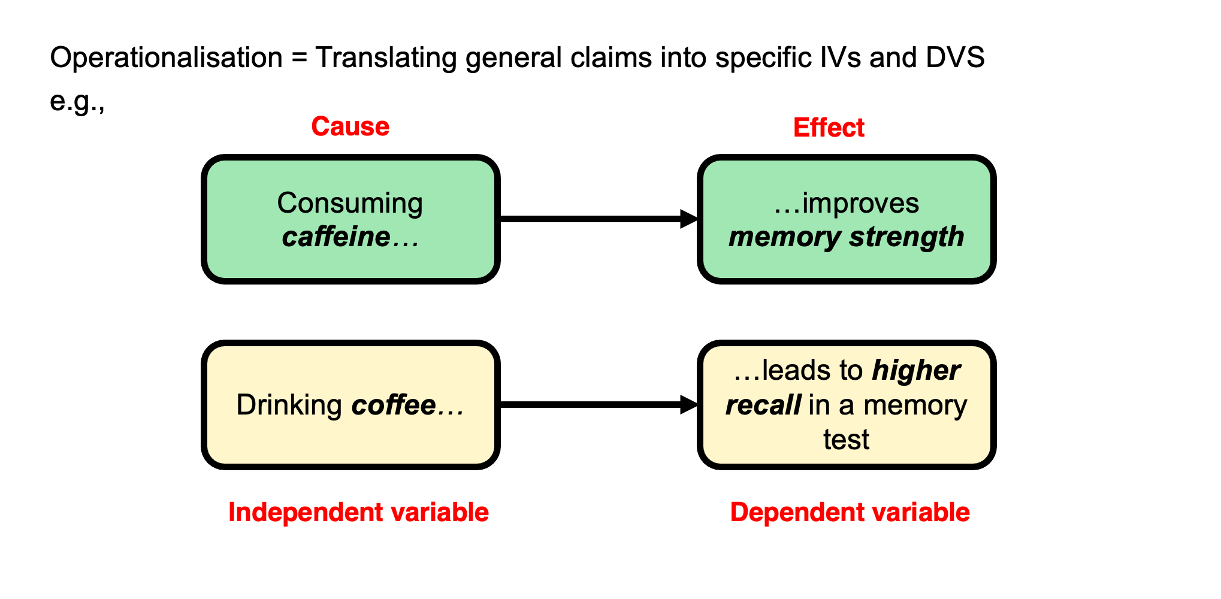

A toy example
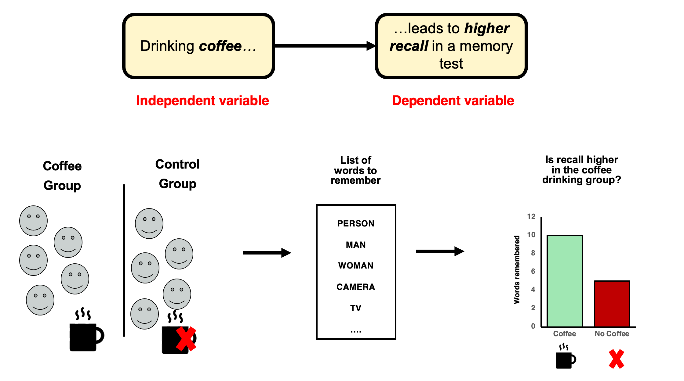

Extraneous variables
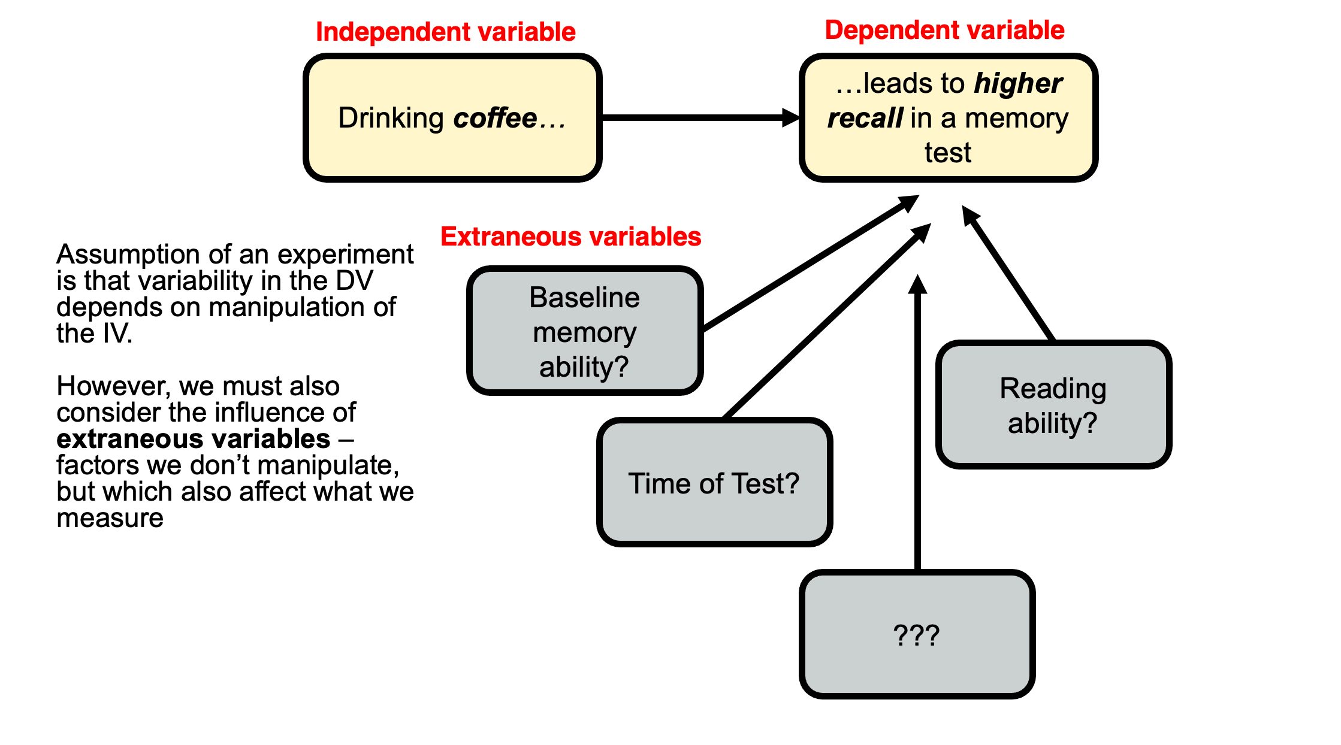

Usually…
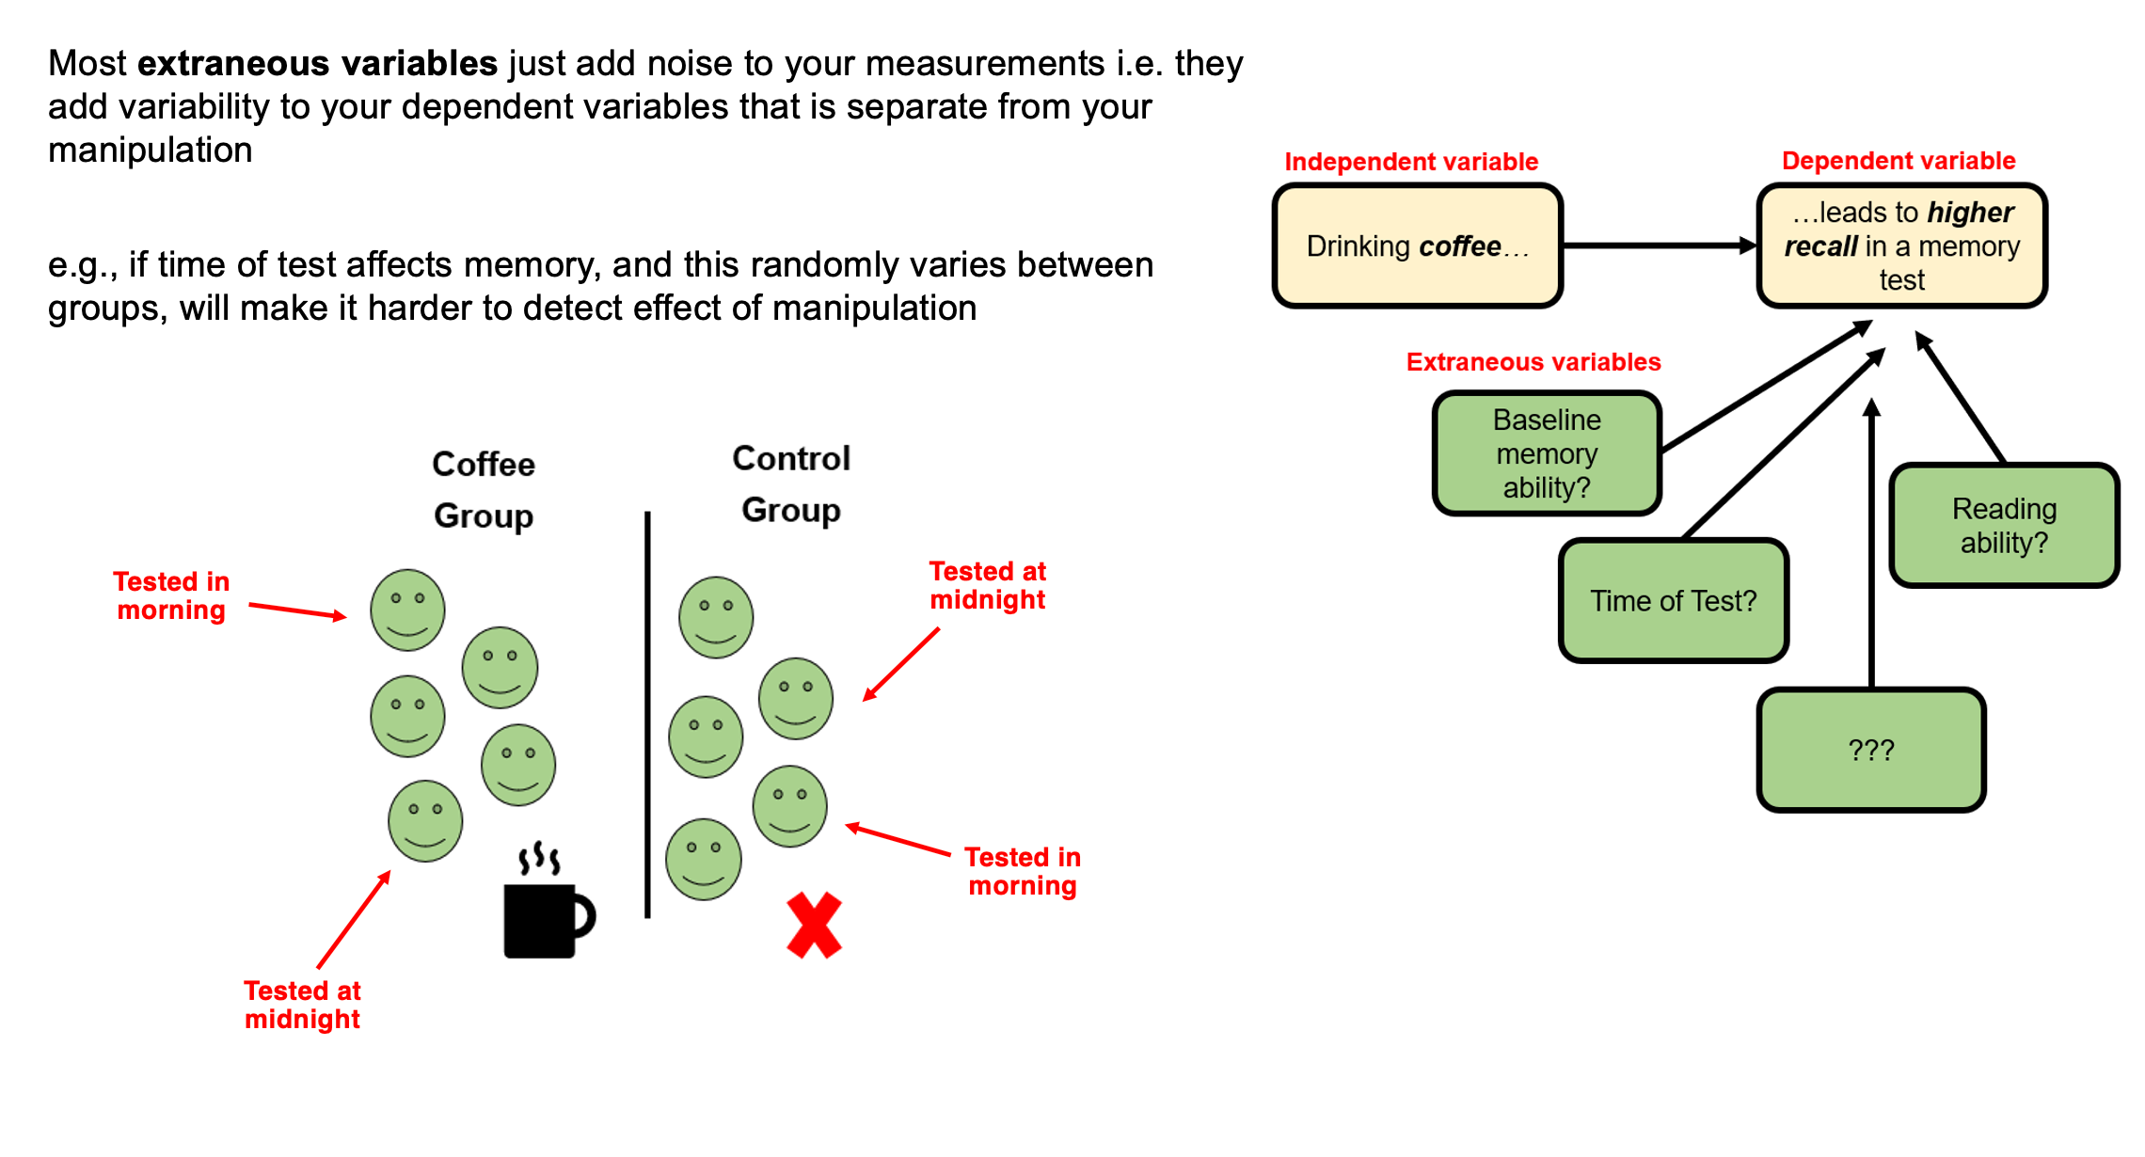

but occasionally…
you hear of ‘confounds’ or ‘confounding variables’
A confounding variable is an extraneous variable that systematically varies with one of your independent variables. These are rare, but nothing can save the experiment.
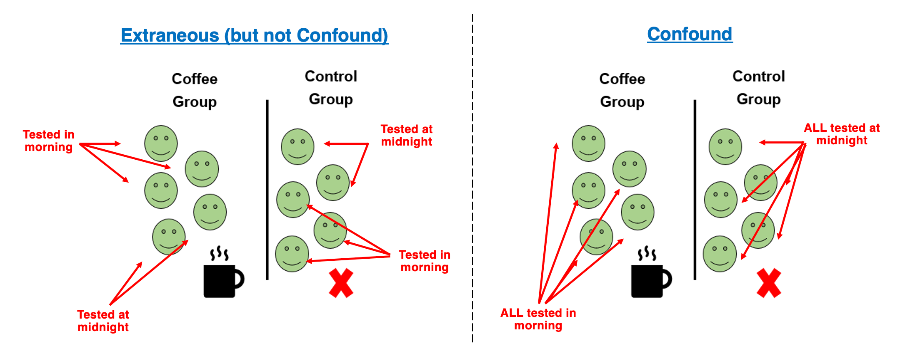

An impossible interpretation
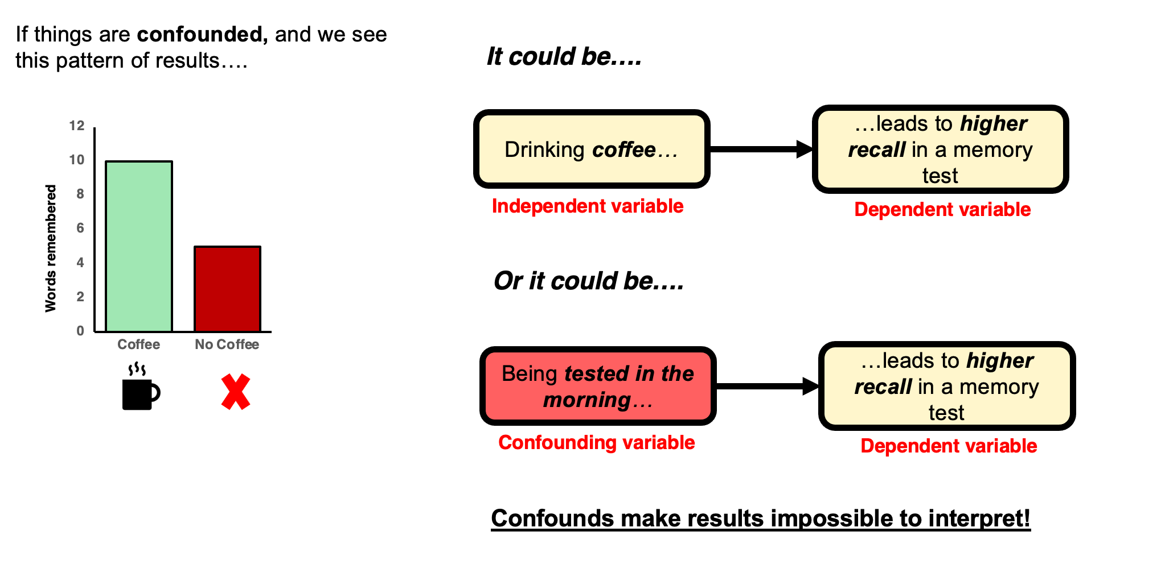

Manipulations almost always introduce potential confounds
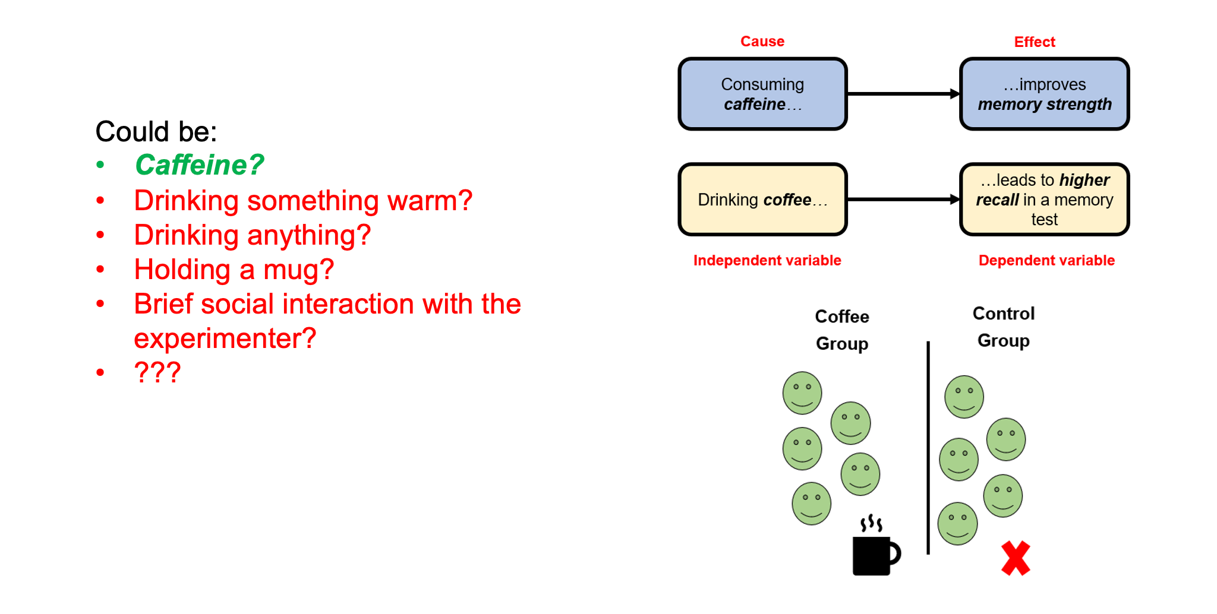

Experimental skill + careful thought + piloting + randomness!
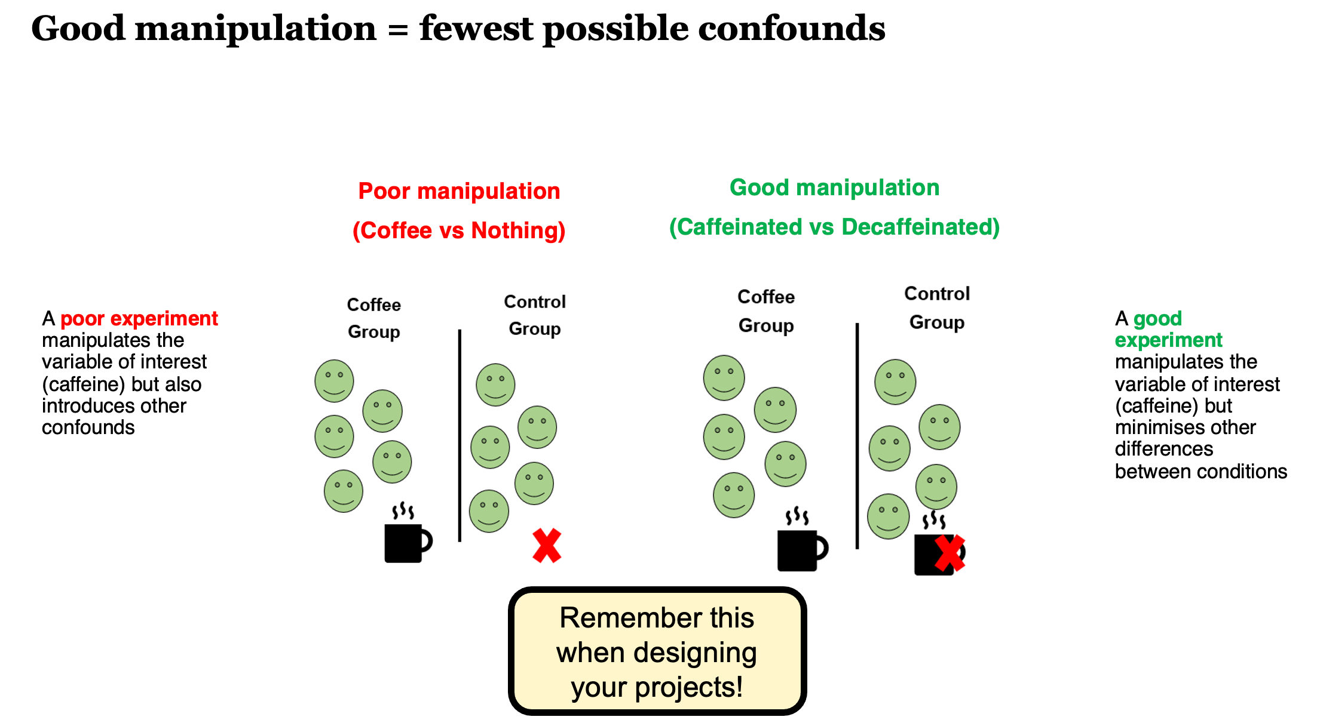

The importance of operationalising your variables well
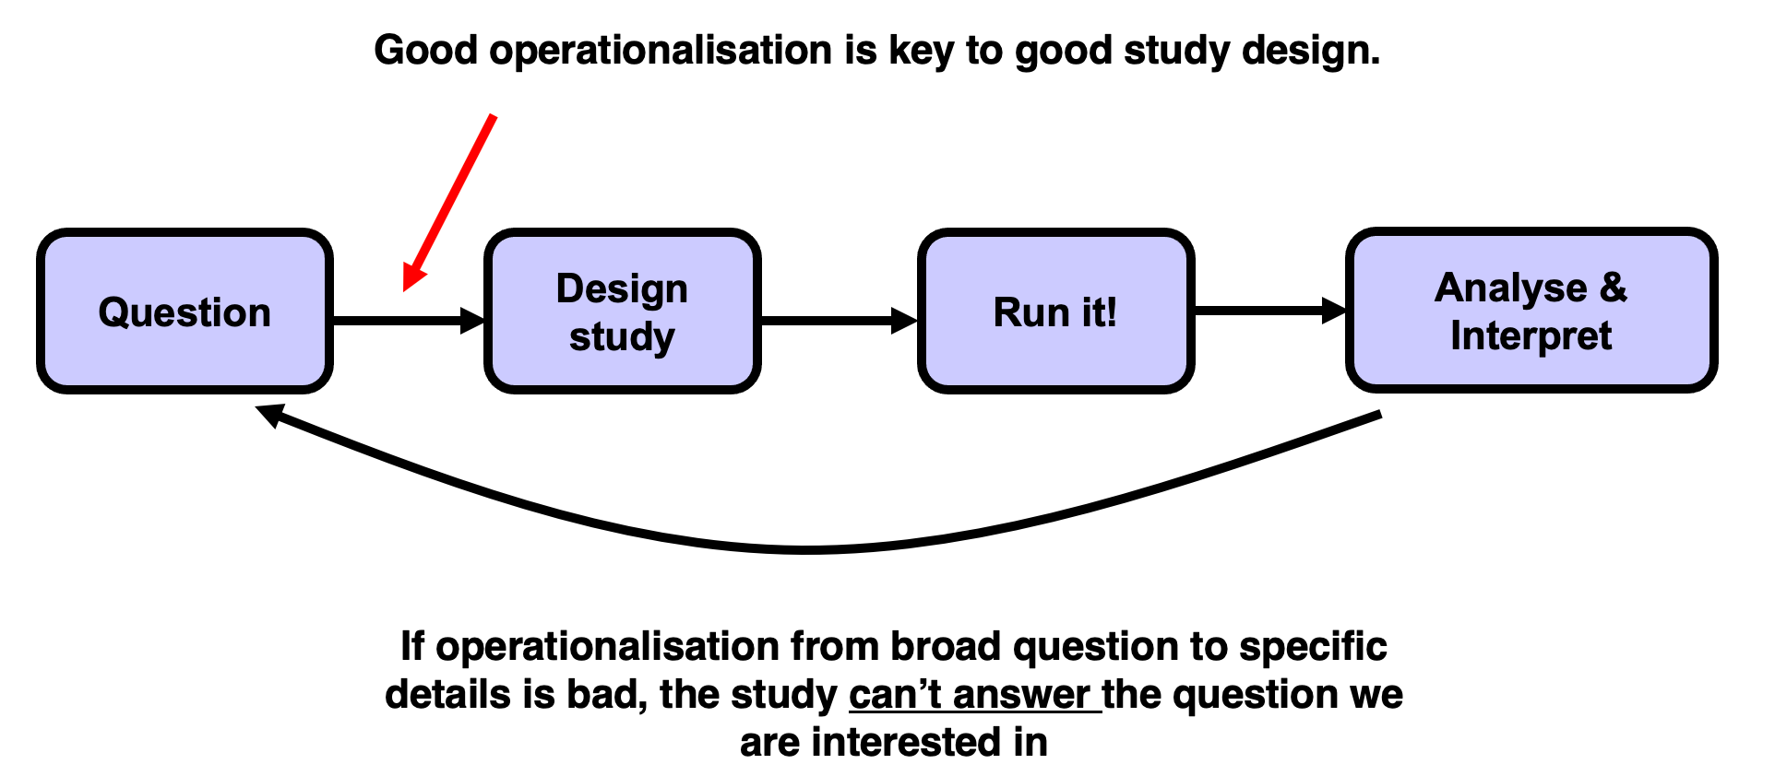

Reading along
I highly recommend reading along with the general topics we cover in the first few weeks.
Research Methods in Psychology by Dennis Howitt and Duncan Cramer is excellent. Chapter 2 in that book (right at the top of the module reading list and here) deals with Hypotheses and aims of research, essentially what we cover this week, and Chapter 1 deals with the basics and golden rules of research design and designing good experiments.

Lab preview

Tomorrow
- Complete the Pulse
- Finalise your groups (3 or 4 people, all from same Personal Tutorial group)
  - Submit a list of names to your Lab Tutor
  - Discuss any problems you are facing
- Agree a broad general focus for your group research and write it in your lab notebook
  - This is now functioning and available in the right hand margin of the VLE page. It’s an experiment, so please give feedback!
- Start establishing how you are going to work as a team and identifying milestones

Any Questions?

